ACLED Africa Spatiotemporal Conflict Model
Methods and preliminary validation results for a 100 x 100 km grid-cell monthly prediction design
Project folder: Repository root after cloning
Purpose: This document explains the research design, data processing steps, model structure, validation strategy, robustness checks, and early results from the ACLED spatiotemporal conflict-clustering notebook. It is written for readers who may not be specialists in spatial prediction or machine learning.

Executive summary
- The project studies whether conflict clusters in Africa show evidence of spatiotemporal diffusion: whether recent conflict in nearby locations helps predict conflict in a focal location in the following month.
- The data are ACLED event records for Africa from January 2000 through December 2010. The notebook converts event-level observations into a monthly grid-cell panel and evaluates whether neighboring-cell conflict history adds information beyond local conflict history.
- The first-stage 100 km model produces useful ranking performance. The best extended random forest reaches ROC-AUC around 0.844 and average precision around 0.499 on the 2006-2010 validation period.
- Neighboring-cell variables improve prediction modestly but consistently. At 100 km, the random forest improvement from local history to local plus neighbors is small: ROC-AUC increases from 0.826 to 0.830 and Brier score improves from 0.108 to 0.103.
- The strongest signal remains local persistence: conflict is more likely where conflict occurred recently. The spatial diffusion signal is present but not yet large enough to interpret as a strong standalone effect.

1. Data source and empirical setting
The source data are ACLED event-level records covering conflict and disorder events across Africa. Each row represents a reported event with a date, geographic coordinates, country and subnational location fields, event and sub-event types, involved actors, and reported fatalities. The current notebook uses the 2000-2010 file as the first modeling dataset; a later 2011-2020 file is reserved for a stricter out-of-sample stage.
Table 1. Basic data summary.
Dataset attribute | Value
Event records | 41,299
Countries | 48
Monthly coverage | 132 months
Reported fatalities | 186,188
Share of events with zero fatalities | 63.4%

Table 2. ACLED event-type composition in the 2000-2010 dataset.
Event type | Events | Share of events
Battles | 15298 | 37.0%
Violence against civilians | 13721 | 33.2%
Protests | 4137 | 10.0%
Riots | 3147 | 7.6%
Explosions/Remote violence | 2649 | 6.4%
Strategic developments | 2347 | 5.7%

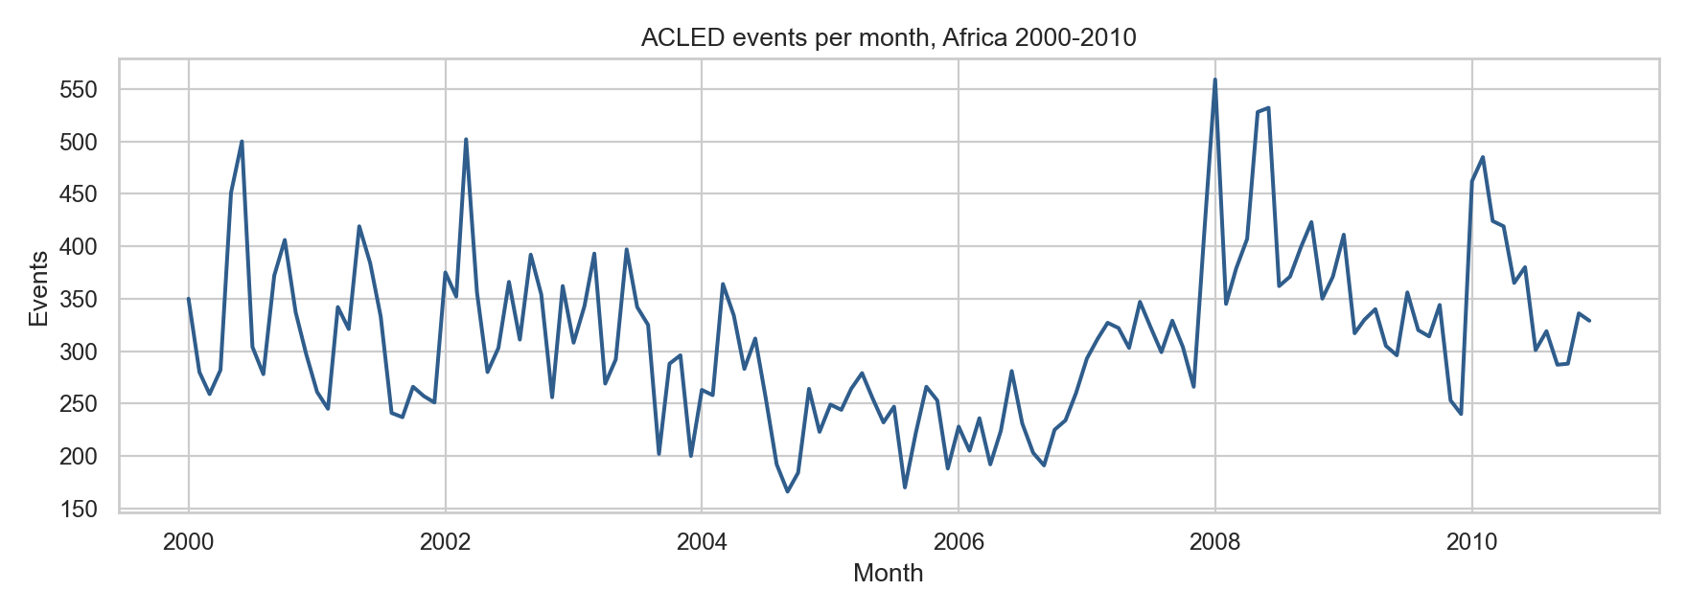
Figure 1. Monthly ACLED event counts, Africa 2000-2010.

2. Research question and hypotheses
The central research question is: do conflict clusters spread over time? Operationally, the notebook asks whether conflict in neighboring grid cells during recent months predicts conflict in a focal grid cell in the next month, after accounting for that cell’s own recent conflict history.
- H1, local persistence: grid cells with recent conflict are more likely to experience conflict in the following month.
- H2, spatial diffusion: conflict in neighboring grid cells increases the probability of conflict in the focal cell in the following month, even after accounting for local persistence.
- H3, scale robustness: the neighbor effect should remain directionally similar across 50 km, 100 km, and 200 km grid definitions if it reflects a broader spatial process rather than an arbitrary grid artifact.

3. Unit of analysis: grid-cell by month
The original ACLED file is not directly a prediction-ready panel. It is a list of events. The notebook therefore constructs a regular analytical panel where each observation is one grid cell in one month. The main grid is approximately 100 x 100 km. This is a pragmatic choice: it is fine enough to capture subnational variation, but not so fine that almost all cell-months become zeros.
- Main specification: approximately 100 x 100 km grid cells observed monthly.
- Robustness specifications: 50 x 50 km and 200 x 200 km grid cells.
- Outcome: whether a grid cell has at least one reported conflict event in the next month.
- Panel restriction: cells are included if they had at least one ACLED event during 2000-2010. This avoids large numbers of ocean, desert, or otherwise irrelevant zero cells in the first-stage design.
Table 3. Main 100 km cell-month panel summary.
Panel feature | Value
Main grid size | 100 km
Cell-month observations | 187,592
Unique cells | 1,432
Validation positive share | 8.6%
Mean events when active | 2.71

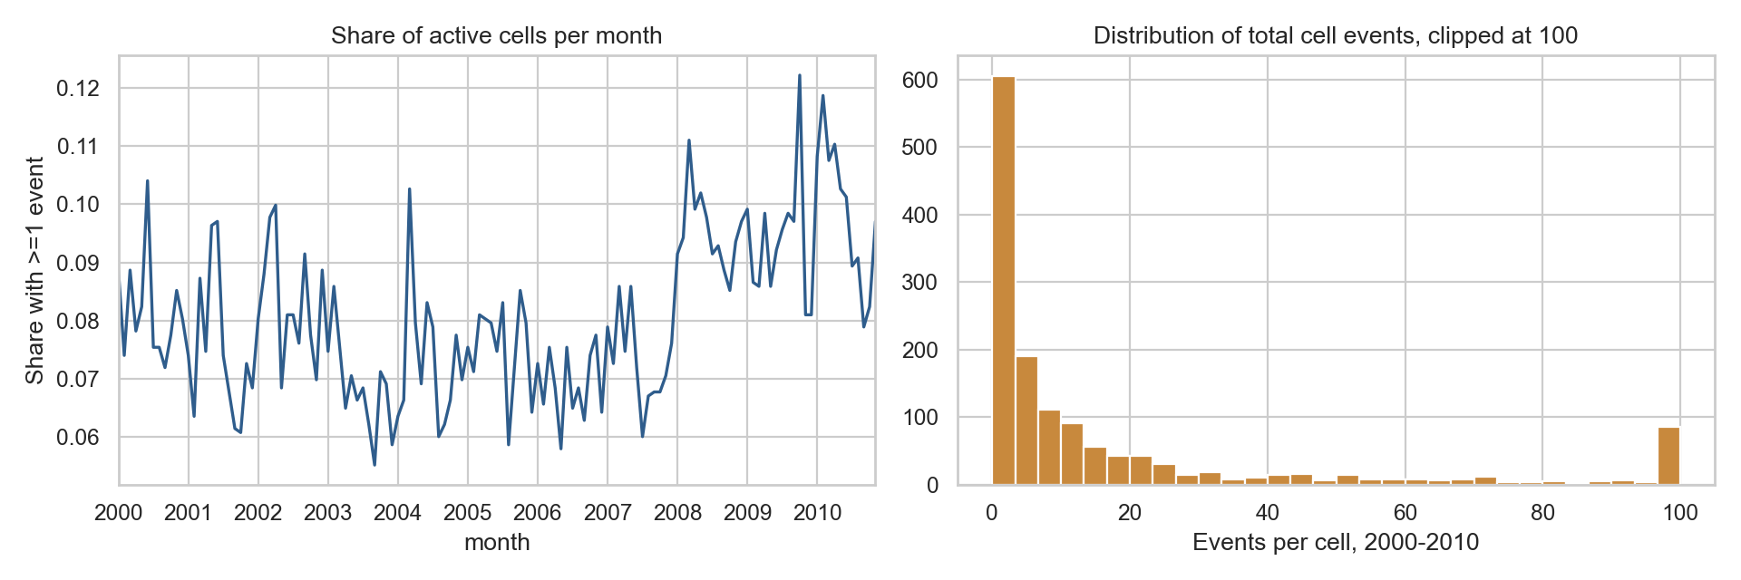
Figure 2. Panel diagnostics for the 100 km grid.

4. Feature construction
Features are variables available before the prediction month. This is important because prediction models must not use future information. The notebook builds three broad groups of features.
- Place and time features: grid x/y position, year, and cyclical month indicators to capture broad spatial and seasonal patterns.
- Local history features: conflict counts, binary conflict indicators, fatalities, and rolling event totals from previous months in the same grid cell.
- Neighbor features: event counts, fatalities, and number of active neighboring cells in the eight surrounding grid cells, lagged so they only represent information from earlier months.

5. Model comparison strategy
The notebook compares models in a staged way. This is important because the main scientific question is not simply whether any model can predict conflict, but whether adding neighboring-cell information improves prediction relative to a model that already knows the cell’s own conflict history.
Table 4. Feature sets used in the model comparison.
Feature set | Purpose
A_place_time | Baseline spatial and temporal structure.
B_local_history | Tests local persistence by adding previous conflict in the same cell.
C_local_plus_neighbors | Tests spatial diffusion by adding lagged conflict in neighboring cells.
D_extended | Adds fatalities and event-type variables for a richer predictive specification.

Two model families are used. Logistic regression provides a more interpretable statistical baseline. Random forest provides a flexible non-linear model that can capture interactions and threshold-like patterns without specifying them manually.

6. Evaluation metrics
The validation period is 2006-2010. The notebook avoids random train-test splitting because random splits in time-dependent conflict data risk leaking future information into model development. Several metrics are used because rare-event prediction cannot be judged well with a single score.
- ROC-AUC measures ranking quality across thresholds. It is useful but can look optimistic in rare-event settings.
- Average precision summarizes the precision-recall curve and is more informative when positive outcomes are rare.
- Brier score measures probabilistic error; lower values indicate better calibrated risk predictions.
- Precision@top-k asks whether the highest-risk cells are actually conflict-prone, which is useful for risk screening.
- F1 is reported only after optimizing the threshold. The base-rate threshold is not substantively useful because it flags too many cells as positive.

7. Main 100 km validation results
Table 5. Main 100 km validation results, selected metrics.
Model | ROC-AUC | Average precision | Brier score
RF_D_extended | 0.844 | 0.499 | 0.112
Logit_D_extended | 0.837 | 0.498 | 0.131
RF_C_local_plus_neighbors | 0.830 | 0.476 | 0.103
RF_B_local_history | 0.826 | 0.474 | 0.108
Logit_C_local_plus_neighbors | 0.825 | 0.470 | 0.133
Logit_B_local_history | 0.810 | 0.466 | 0.133

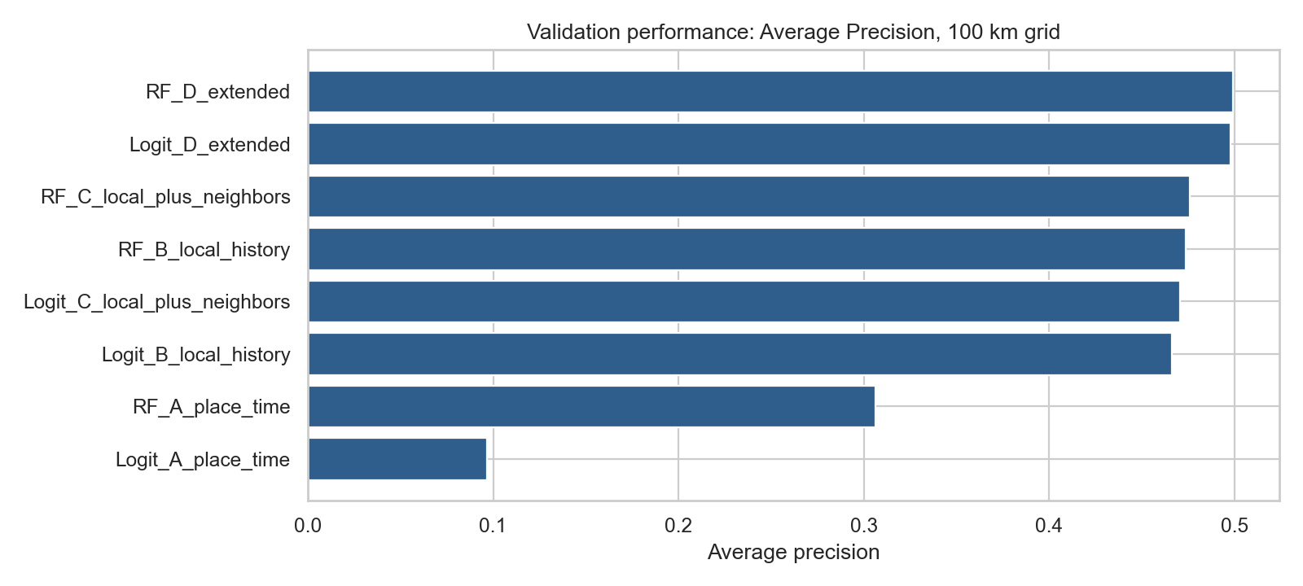
Figure 3. Average precision by model, 100 km validation period.
The results show that local conflict history substantially improves prediction relative to a simple place-time baseline. For the random forest, average precision increases from approximately 0.306 in the place-time model to 0.474 after adding local history. Adding neighboring-cell features gives a further but smaller improvement, with average precision rising to approximately 0.476 and Brier score improving from 0.108 to 0.103.
Table 6. Neighbor uplift: local plus neighbors compared with local history only.
Model family | Delta ROC-AUC, C-B | Delta average precision, C-B | Delta Brier, C-B
RF | 0.003 | 0.002 | -0.005
Logit | 0.015 | 0.005 | -0.001

Interpretation: The neighbor effect is positive but modest. This is consistent with a weak spatial diffusion signal, but the dominant predictive pattern is still local persistence: recent conflict in the same cell is the strongest first-stage predictor.

8. Threshold-sensitive diagnostics
The original base-rate threshold produced low and uninformative F1 values because several models classified almost every validation observation as positive. The revised notebook therefore separates ranking performance from threshold choice and reports F1-optimal thresholds.
Table 7. F1-optimal thresholds for selected 100 km models.
Model | F1-optimal threshold | Precision | Recall | F1 | Predicted positive share
RF_B_local_history | 0.690 | 0.487 | 0.464 | 0.475 | 0.082
RF_C_local_plus_neighbors | 0.630 | 0.456 | 0.490 | 0.472 | 0.093
RF_D_extended | 0.676 | 0.500 | 0.476 | 0.487 | 0.082
Logit_C_local_plus_neighbors | 0.688 | 0.468 | 0.482 | 0.475 | 0.089

Table 8. Precision among the highest-risk validation cell-months.
Model | Flagged share | Precision | Recall captured | Lift vs base rate
RF_B_local_history | 1% | 0.871 | 0.101 | 10.128
RF_B_local_history | 5% | 0.603 | 0.351 | 7.010
RF_B_local_history | 10% | 0.436 | 0.507 | 5.070
RF_C_local_plus_neighbors | 1% | 0.871 | 0.101 | 10.128
RF_C_local_plus_neighbors | 5% | 0.599 | 0.348 | 6.966
RF_C_local_plus_neighbors | 10% | 0.438 | 0.510 | 5.098
RF_D_extended | 1% | 0.889 | 0.103 | 10.334
RF_D_extended | 5% | 0.615 | 0.358 | 7.153
RF_D_extended | 10% | 0.452 | 0.526 | 5.257

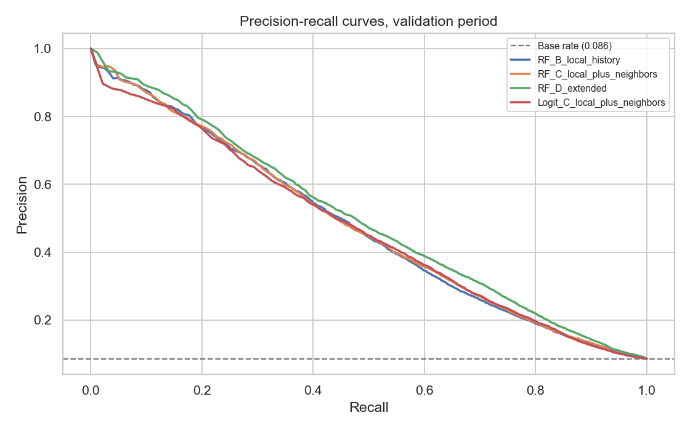
Figure 4. Precision-recall curves for selected 100 km models.
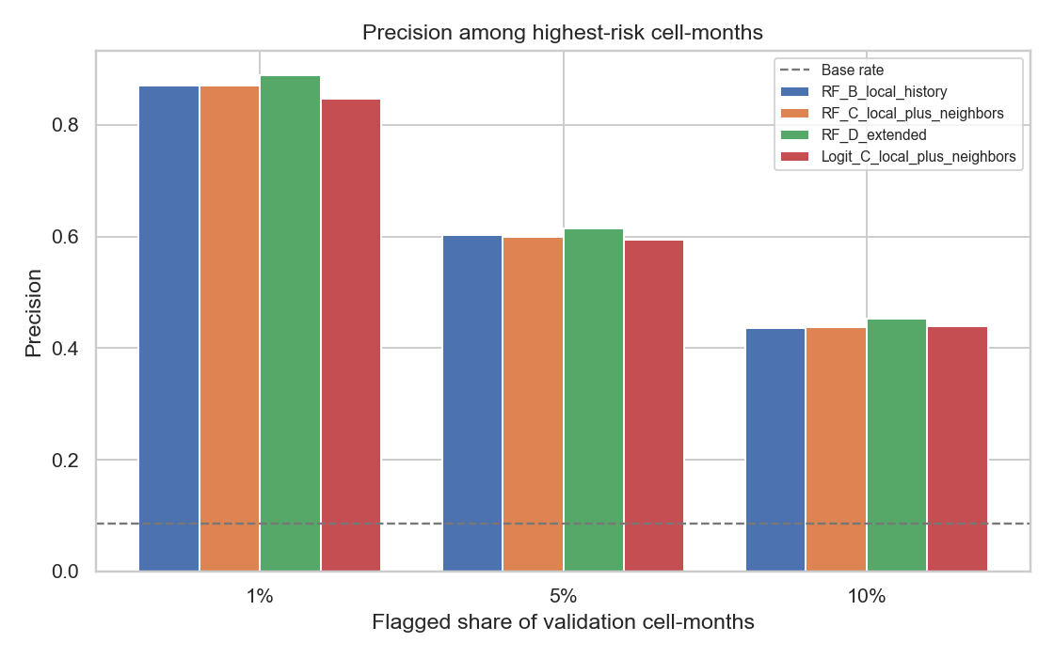
Figure 5. Precision among highest-risk cell-months.
The top-risk diagnostics are encouraging. In the highest-risk 1% of validation cell-months, random forest models achieve precision around 0.87-0.89, roughly ten times the validation base rate. This means that even when the neighbor uplift is modest, the model ranks some cell-months as meaningfully high risk.

9. Robustness checks across grid sizes
Table 9. Random forest robustness results across grid sizes.
Grid km | Model | Cells | Validation positive share | ROC-AUC | Average precision | Brier score
50 | RF_C_local_plus_neighbors | 2702 | 0.054 | 0.796 | 0.359 | 0.085
50 | RF_B_local_history | 2702 | 0.054 | 0.790 | 0.355 | 0.089
100 | RF_C_local_plus_neighbors | 1432 | 0.086 | 0.830 | 0.476 | 0.103
100 | RF_B_local_history | 1432 | 0.086 | 0.826 | 0.474 | 0.108
200 | RF_C_local_plus_neighbors | 603 | 0.156 | 0.858 | 0.632 | 0.122
200 | RF_B_local_history | 603 | 0.156 | 0.855 | 0.629 | 0.127

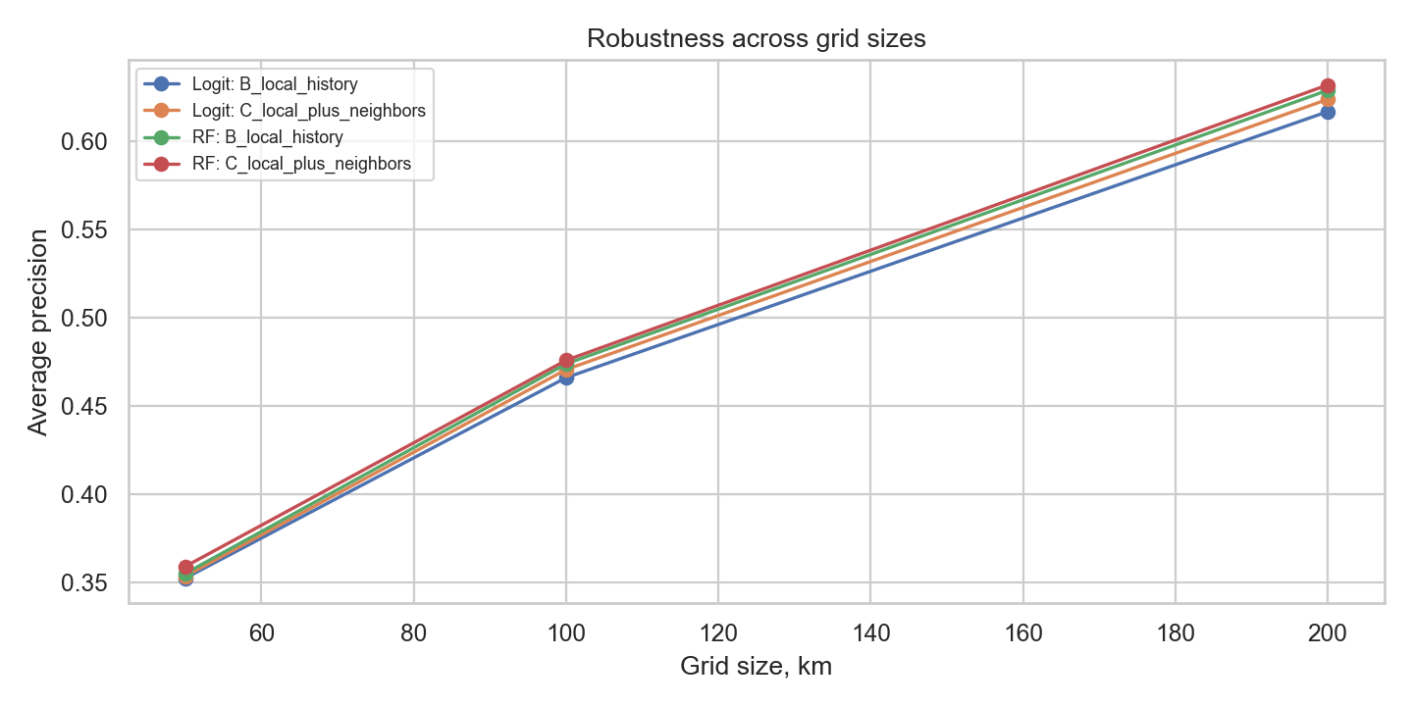
Figure 6. Robustness of average precision across grid sizes.
The directional pattern is stable: adding neighboring-cell features improves average precision slightly at 50 km, 100 km, and 200 km. The absolute scores increase with coarser grids, partly because larger cells have higher positive rates and aggregate more events. Therefore, the 200 km performance should not be interpreted as automatically superior; it trades geographic precision for a less sparse prediction target.

10. Spatial sanity check
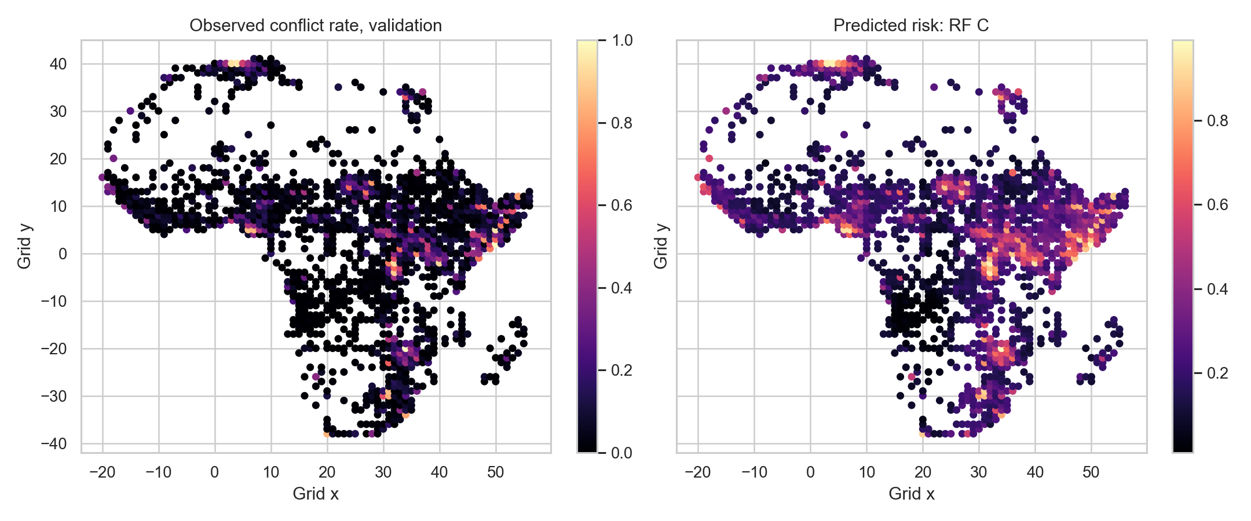
Figure 7. Observed versus predicted risk by 100 km grid cell in the validation period.
The map-like diagnostic is not a formal cartographic product, but it is useful for checking whether high predicted risk is geographically plausible. A later version could use a proper equal-area projection, country boundaries, and possibly a land or population mask.

11. Limitations and next steps
- The grid uses an approximate kilometer conversion rather than a formal equal-area projection. This is acceptable for a first modeling pass but should be upgraded for publication-quality spatial analysis.
- The panel includes only cells with at least one event during 2000-2010. A later design should use a land mask or population raster to define the at-risk set more systematically.
- ACLED records reported events. Variation in media access, reporting intensity, and coding practices may affect observed conflict patterns.
- The current design is predictive rather than causal. Neighboring conflict can indicate diffusion, shared drivers, or reporting patterns; it does not prove that conflict in one cell causes conflict in another.
- The next modeling stage should reserve 2011-2020 as a strict final out-of-sample test and should consider separate models for battles, violence against civilians, and remote violence.

Appendix: Notebook outputs and reproducibility
The analysis is implemented in the notebook located at notebooks/acled_spatiotemporal_grid_model.ipynb. Outputs are written to structured folders: tables, figures, and panels. The document was generated from these outputs rather than hand-entered results, so the reported numbers should remain consistent with the current notebook run.

